LAB 9: TO IMPLEMENT HALF- ADDER USING 2:4 DECODER

Name: Shreyas Sawant Div: D7A Roll No.: 55

A=0 B=0

Sum=0 Carry=0

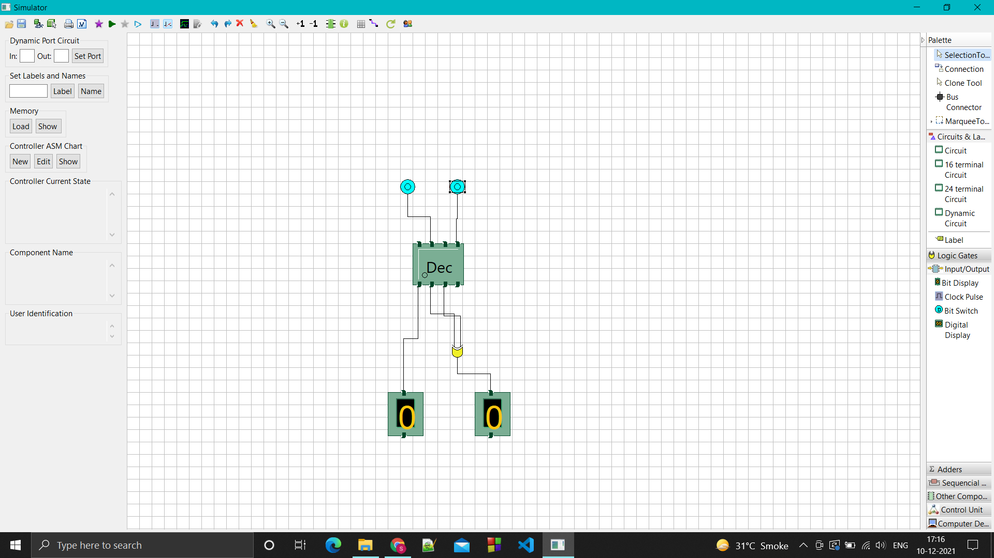

A=0 B=1

Sum=1 Carry=0

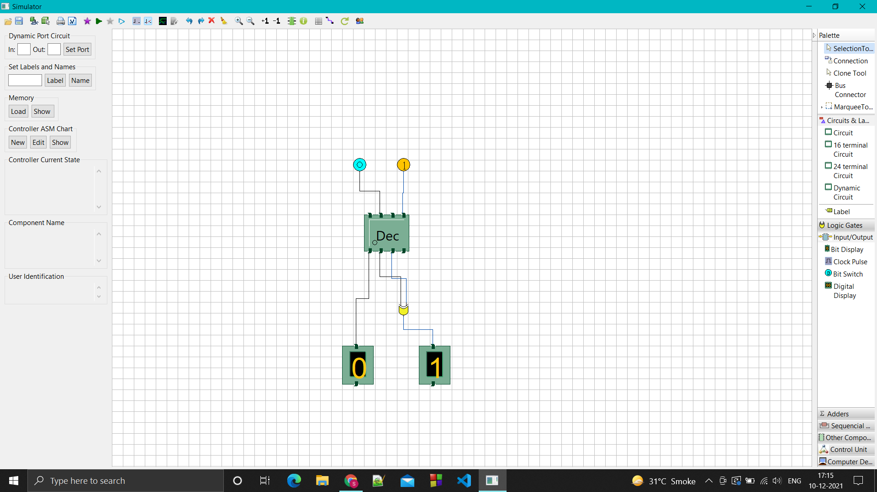

A=1 B=0

Sum=1 Carry=0

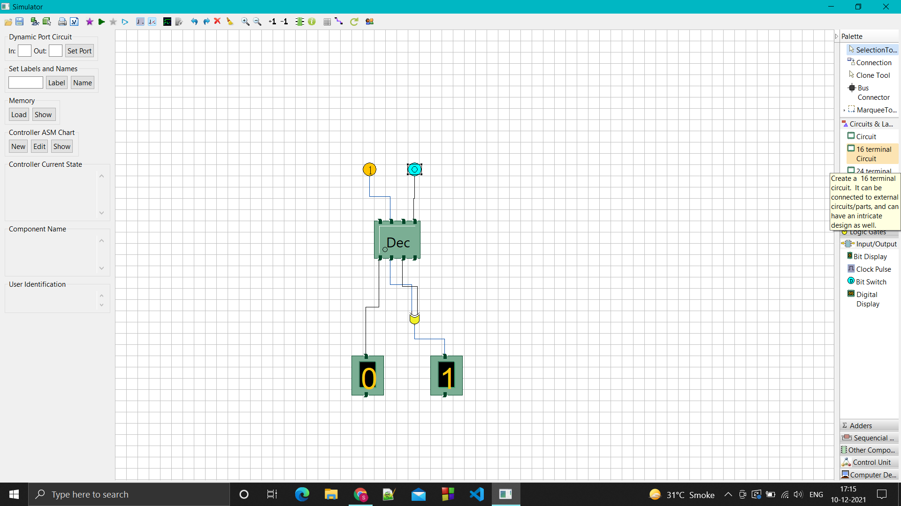

A=1 B=1

Sum=0 Carry=1

